Retail Business Performance & Profitability Analysis
Objective: Analyze transactional retail data to uncover profit-draining categories, optimize inventory turnover, and identify seasonal product behavior.
Tools: SQL, Python (Pandas, Seaborn), Power BI
Mini Guide:
- Import data into SQL and clean missing/null records
- Use SQL to calculate profit margins by category and sub-category
- Use Python (Pandas) to run correlation between inventory days and profitability
- Build dashboard with filters for region, product type, and season
- Derive strategic suggestions for slow-moving and overstocked items
Deliverables:
- Power BI Dashboard
- SQL queries (.sql file)
- PDF Report with key insights
Introduction :
To analyze a retail company’s sales and profitability performance across regions, products, and customer segments to answer key business questions:
- Which products and regions generate the most revenue and profit?
- What are the monthly/seasonal sales trends?
- Who are the most valuable customers?
- How can pricing, discounting, or product mix be optimized to increase profitability?
Tools & Tech Stack
Tool | Usage
SQL (MySQL / PostgreSQL) | Data extraction, transformation, and KPIs computation
Excel | Data validation, pivot summaries, quick exploration
Jupyter Notebook (Python + Pandas + Matplotlib/Seaborn) | Data wrangling, statistical analysis, correlation, and visualization
Power BI | Interactive dashboards for performance and profitability tracking
Abstract
Dataset Design
We’ll use (or generate) 3 interrelated tables to simulate a real business scenario:
sales_data
Column | Type | Description
Transaction_ID | INT | Unique transaction ID
Order_Date | DATE | Date of sale
Product_ID | INT | Foreign key to products
Customer_ID | INT | Foreign key to customers
Region | VARCHAR | Sales region (North, South, East, West)
Units_Sold | INT | Quantity sold
Unit_Price | FLOAT | Price per unit
Discount | FLOAT | Discount applied
Total_Sales | FLOAT | Units_Sold × Unit_Price × (1 - Discount)
Profit | FLOAT | (Unit_Price - Cost_Price) × Units_Sold

products
Column | Type | Description
Product_ID | INT | Product unique ID
Product_Name | VARCHAR | Product name
Category | VARCHAR | Product category (e.g., Electronics, Clothing, Furniture)
Cost_Price | FLOAT | Cost to retailer per unit

customers
Column | Type | Description
Customer_ID | INT | Unique customer ID
Customer_Name | VARCHAR | Full name
Segment | VARCHAR | Customer segment (e.g., Retail, Corporate, Consumer)

Steps involved in the project:
Phase 1: Data Setup (SQL)
- Create database retail_performance_db
- Import CSVs into SQL tables
- Clean data: handle nulls, date formatting, etc.
- Create calculated columns & KPIs:

Phase 2: Excel Exploration
- Import SQL export → Excel
- Build Pivot Tables:
  - Total Sales by Category
  - Profit % by Region
  - Top 5 Customers by Spend
- Add conditional formatting and slicers

Phase 3: Analysis in Jupyter Notebook (Python)
Use Python to go deeper into data insights.
Tasks:
- Monthly trend analysis
- Category-wise profitability visualization
- Discount vs Profit correlation
- Detect outliers or anomalies in sales
Phase 4: Dashboard in Power BI
Create an interactive Retail Business Dashboard with:
KPIs
- Total Sales
- Total Profit
- Profit Margin (%)
- Average Order Value
- YoY Growth %
Visuals
- Sales Trend (Line Chart)
- Profit by Region (Map or Bar)
- Category Performance (Donut Chart)
- Top 10 Products (Table)
- Customer Segment Contribution (Stacked Bar)
Add slicers: Date | Region | Category | Segment
Phase 5: Insights & Reporting
Write a short executive summary:
- Top-performing category and region
- Month with highest sales
- Which discounts improved sales but hurt profit
- Strategic recommendations (e.g., optimize low-margin products, expand top regions)

Deliverables
File | Description
sales_data.csv, products.csv, customers.csv | Datasets
retail_analysis.sql | SQL queries for KPI calculations
retail_EDA.ipynb | Jupyter Notebook analysis
retail_summary.xlsx | Excel pivot dashboards
retail_dashboard.pbix | Power BI interactive report

1) SQL: Import & clean (MySQL)
Create database & tables

CREATE DATABASE retail_performance;
USE retail_performance;

Product table
CREATE TABLE Product (
Product_ID VARCHAR (10) PRIMARY KEY,
Product_Name VARCHAR (100),
Category VARCHAR (50),
Sub_Category VARCHAR (50),
Cost_Price DECIMAL (10,2),
Stock_On_Hand INT
);

Customer Table

CREATE TABLE Customer (
Customer_ID VARCHAR(50) PRIMARY KEY,
Customer_Name VARCHAR (100),
Segment VARCHAR(50)
);

Sales data table

CREATE TABLE sales_data (
Transaction_ID VARCHAR(12) PRIMARY KEY,
Order_Date DATE,
Product_ID VARCHAR(10),
Customer_ID VARCHAR(10),
Region VARCHAR(20),
Units_sold INT,
Unit_price DECIMAL (10,2),
Discount DECIMAL(5,2),
Total_sales DECIMAL (12,2),
Profit DECIMAL (12,2)
FOREIGN KEY (Product_ID) REFERENCES products (Product_ID)
FOREIGN KEY (Customer_ID) REFERENCES customers (Customer_ID)
);

Cleaning missing / null records
Find rows with nulls
SELECT COUNT(*) AS null_counts,
SUM(CASE WHEN Order_Date IS NULL THEN 1 ELSE 0 END) AS missing_order_date,
SUM(CASE WHEN Product_ID IS NULL THEN 1 ELSE 0 END) AS missing_product_id,
SUM(CASE WHEN Total_Sales IS NULL THEN 1 ELSE 0 END) AS missing_total_sales
FROM sales_data;
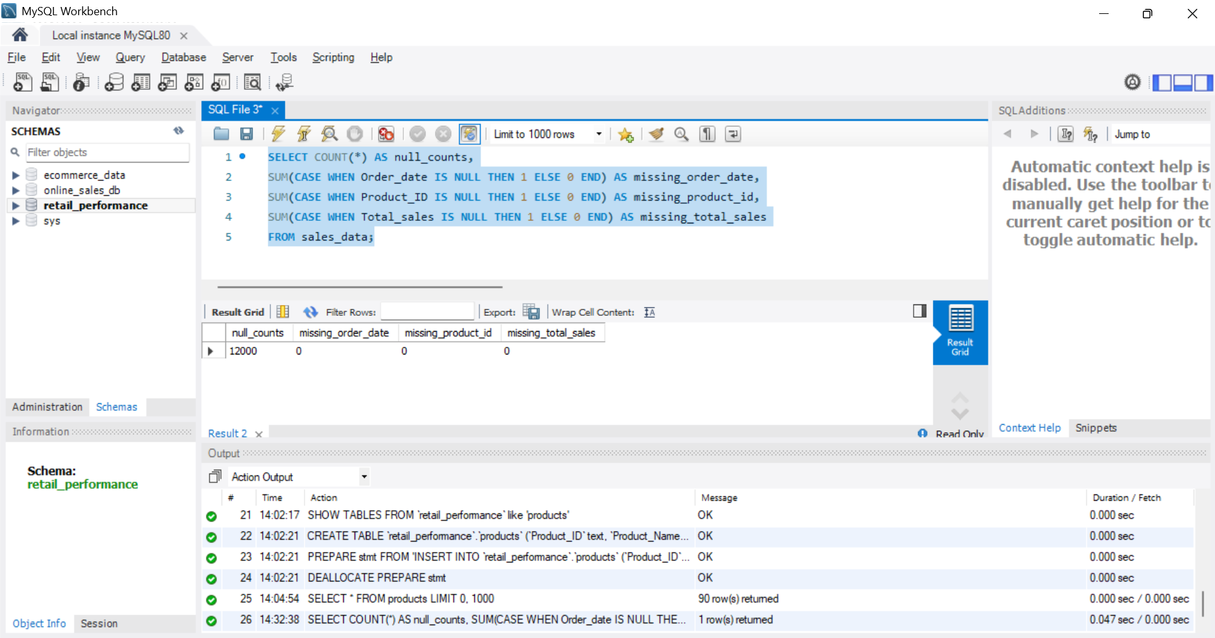

Remove transactions with essential missing data (e.g., missing Product_ID or Order_Date)

DELETE FROM sales_data
WHERE Product_ID IS NULL OR Order_Date IS NULL;

Impute or mark missing prices/profits with 0 and flag
ALTER TABLE sales_data ADD COLUMN data_issue_flag VARCHAR(100);

UPDATE sales_data
SET data_issue_flag = CONCAT_WS(';',
CASE WHEN Unit_Price IS NULL THEN 'missing_unit_price' END,
CASE WHEN Total_Sales IS NULL THEN 'missing_total_sales' END,
CASE WHEN Profit IS NULL THEN 'missing_profit' END
)
WHERE Unit_Price IS NULL OR Total_Sales IS NULL OR Profit IS NULL;

UPDATE sales_data
SET Unit_Price = COALESCE(Unit_Price, 0),
Total_Sales = COALESCE(Total_Sales, 0),
Profit = COALESCE(Profit, 0);

Fill null numeric fields with 0 to avoid aggregation errors (after flagging)
UPDATE sales_data
SET Unit_Price = COALESCE(Unit_Price, 0),
Total_Sales = COALESCE(Total_Sales, 0),
Profit = COALESCE(Profit, 0);

2) Use SQL to calculate profit margins by category and sub-category

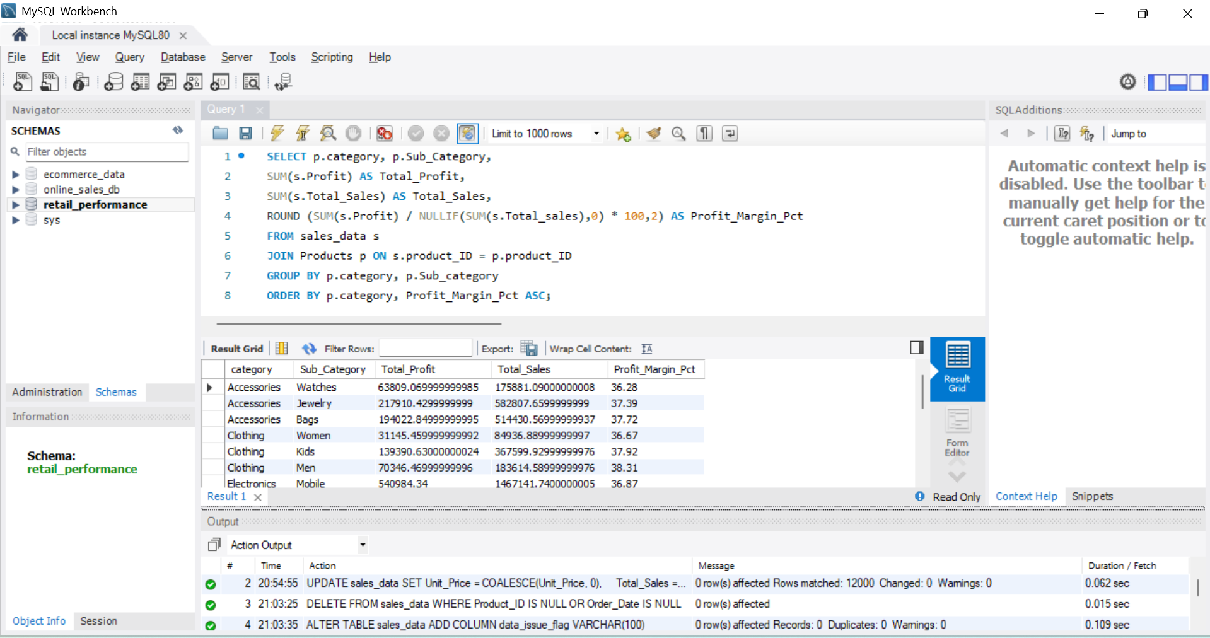

SELECT p.category, p.Sub_Category,
SUM(s.Profit) AS Total_Profit,
SUM(s.Total_Sales) AS Total_Sales,
ROUND (SUM(s.Profit) / NULLIF(SUM(s.Total_sales),0) * 100,2) AS Profit_Margin_Pct
FROM sales_data s
JOIN Products p ON s.product_ID = p.product_ID
GROUP BY p.category, p.Sub_category
ORDER BY p.category, Profit_Margin_Pct ASC;

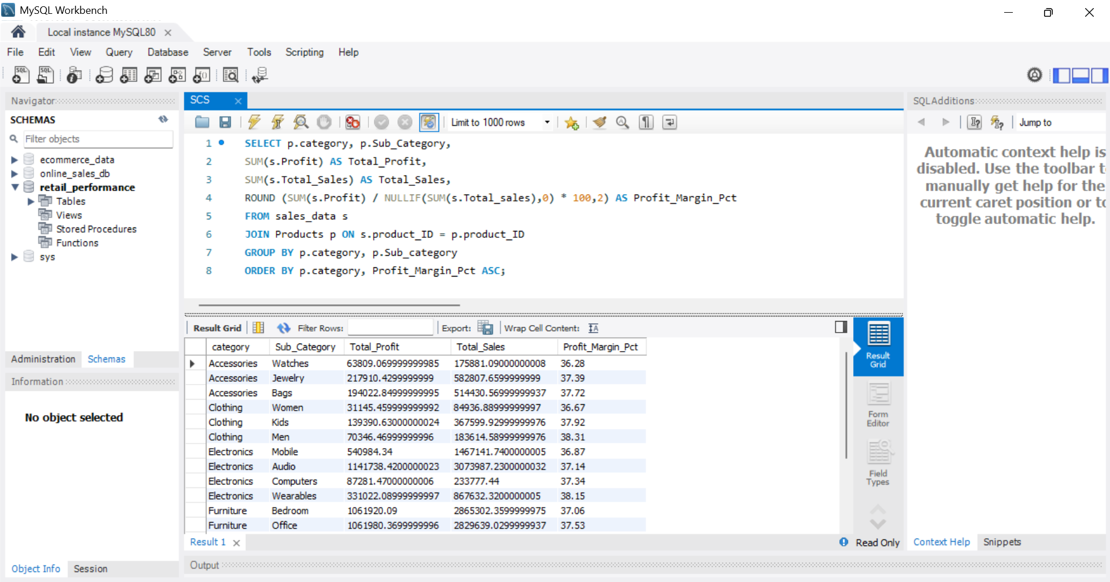

Python (Pandas): correlation between inventory days and profitability

import pandas as pd
import numpy as np
from scipy.stats import pearsonr

products = pd.read_csv('products.csv')
sales = pd.read_csv('sales_data.csv', parse_dates=['Order_Date'])

# Aggregations per product
prod_sales = sales.groupby('Product_ID').agg(
total_units_sold = ('Units_Sold', 'sum'),
total_sales = ('Total_Sales', 'sum'),
total_profit = ('Profit', 'sum'),
first_sale = ('Order_Date','min'),
last_sale = ('Order_Date','max'),
transactions = ('Transaction_ID','count')
).reset_index()

df = prod_sales.merge(products, on='Product_ID', how='left')

df['profit_margin_pct'] = np.where(df['total_sales']>0, df['total_profit']/df['total_sales']*100, 0)
df['days_active'] = (df['last_sale'] - df['first_sale']).dt.days + 1
df['days_active'] = df['days_active'].fillna(1).replace(0,1)
df['avg_daily_units_sold'] = df['total_units_sold'] / df['days_active']

# inventory_days: stock_on_hand / avg_daily_units_sold
df['inventory_days'] = df['avg_daily_units_sold'].replace(0, np.nan)
df['inventory_days'] = df.apply(lambda r: r['Stock_On_Hand']/r['avg_daily_units_sold'] if r['avg_daily_units_sold']>0 else np.nan, axis=1)
df['inventory_turnover'] = np.where(df['Stock_On_Hand']>0, df['total_units_sold']/df['Stock_On_Hand'], np.nan)

# correlation
corr_df = df.dropna(subset=['inventory_days','profit_margin_pct'])
corr_coef, p_value = pearsonr(corr_df['inventory_days'], corr_df['profit_margin_pct'])

print("Pearson correlation between inventory_days and profit_margin_pct:", corr_coef, "p-value:", p_value)

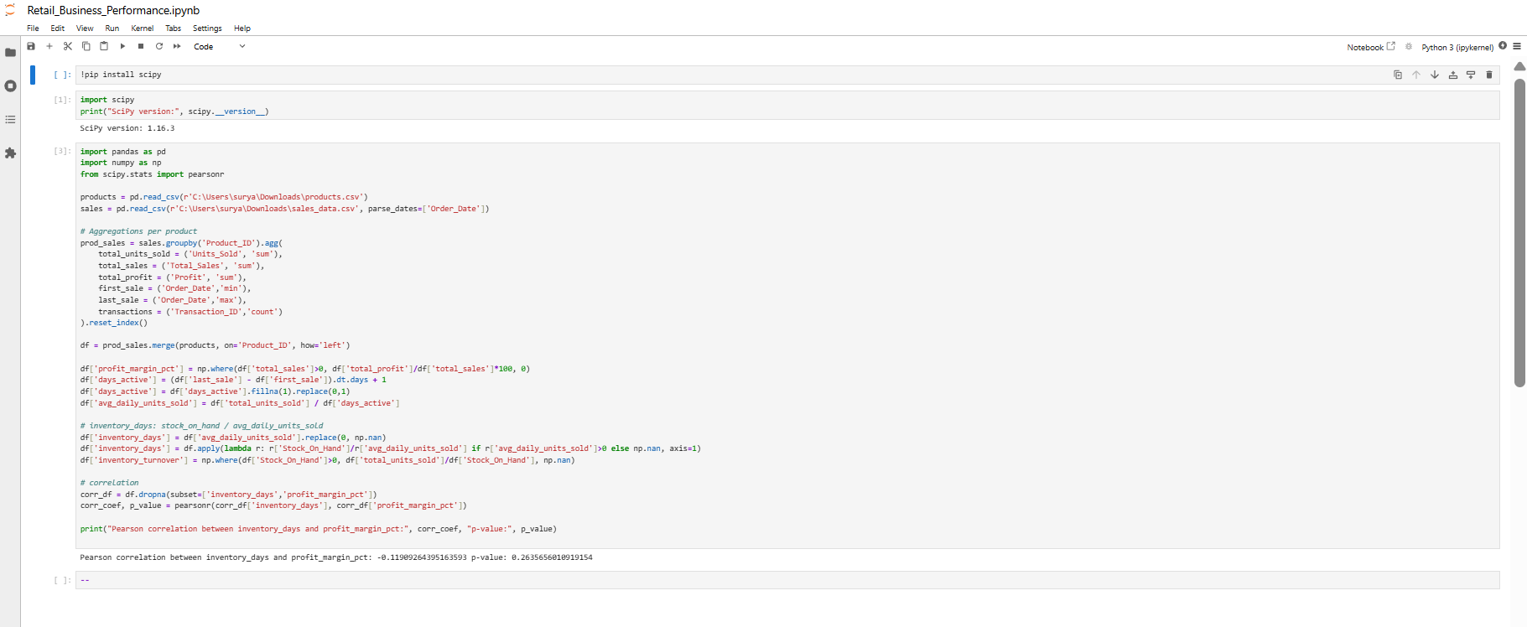

Result I obtained from the generated dataset
- Pearson correlation coefficient = -0.1191
- p-value = 0.2636
Interpretation: a weak negative correlation (not statistically significant at common thresholds), suggesting that in this dataset there is a slight tendency for products with higher inventory days to have lower profit margins, but the relationship is weak and not statistically significant — further segmentation (by category/region) is recommended.
I also produced per-product metrics and identified slow-moving and overstocked items (see next section).

3) Power BI: Dashboard guidance & DAX measures
Build dashboard with filters for region, product type, and season

Inventory Turnover
Inventory Turnover =
DIVIDE(
SUM(sales_data[Units_Sold]),
AVERAGE(products[Stock_On_Hand])
)

Inventory Days
Inventory Days =
DIVIDE(365, [Inventory Turnover])

Slow Moving Flag
Slow_Moving =
IF([Inventory Days] > 120, "Slow Moving", "Normal")

Overstock Flag
Overstock =
VAR MonthlyUnits =
CALCULATE(
AVERAGE(sales_data[Units_Sold]),
DATESINPERIOD('Date_Table'[Date], MAX('Date_Table'[Date]), -30, DAY)
)
RETURN
IF(products[Stock_On_Hand] > 3 * MonthlyUnits, "Overstocked", "Normal")

Slow Moving Items Table

Visual Type: Table
Fields to add:
- Product_Name
- Category
- Sub_Category
- Stock_On_Hand
- Units_Sold
- Inventory Days
- Slow_Moving
Overstock Heatmap (Matrix)

Visual Type: Matrix
Rows: Category
Columns: Sub_Category
Values: Stock_On_Hand

Inventory Turnover by Category

Visual Type: Clustered Bar Chart
Axis: Category
Value: Inventory Turnover

Product-Level Risk Scatter Plot

Visual Type: Scatter Chart
X-axis: Inventory Days
Y-axis: Stock_On_Hand
Details: Product_Name
Legend: Slow_Moving or Overstock

Add Slicers

Slicer 1 → Region
Field: sales_data[Region]
Slicer 2 → Product Category
Field: products[Category]
Slicer 3 → Seasons
Field: Date_Table[Seasons]

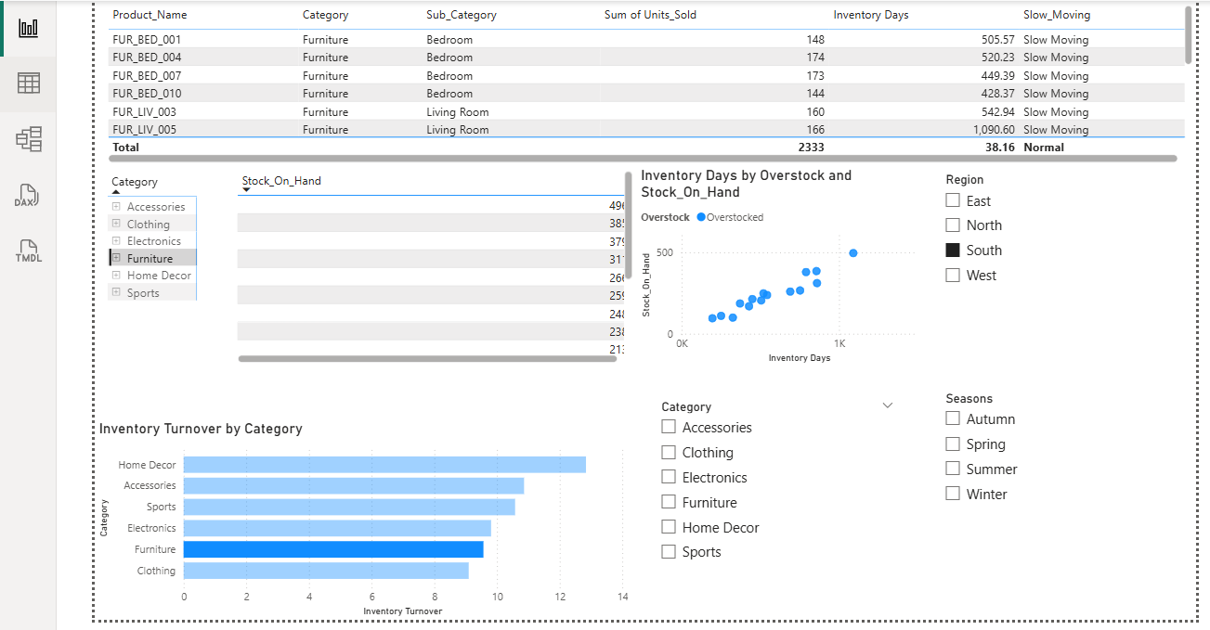

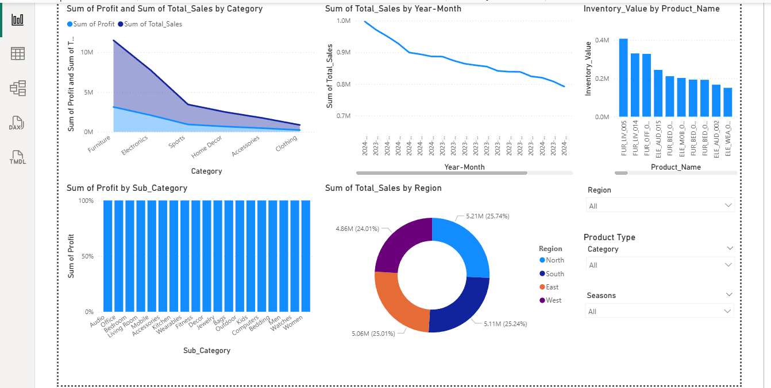

Conclusion:
This project helps understand retail business performance using sales and inventory data in Power BI. The dashboard shows how sales, profit, and inventory behave across products, categories, regions, and time.
What this project achieved:
- Found which categories make good sales but low profit
- Identified slow-moving and overstocked products
- Showed regional sales contribution clearly
- Highlighted sales trends over time and seasonality
- Helped spot products where too much money is stuck in inventory
Why this is useful:
- Helps reduce overstock and storage costs
- Supports better pricing and discount decisions
- Improves inventory planning and forecasting
- Makes business decisions data-driven instead of guesswork
In short:
This dashboard turns raw data into clear insights that help improve profitability, inventory control, and business efficiency.

